**8 Days and 7 Nights Vacation in Sri Lanka**

**Day 1: Colombo Airport to Bentota**

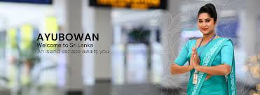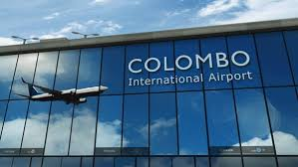

Upon your arrival, our friendly guide will extend a warm welcome, You will be transferred to the hotel as you need to have a rest after long way travelling. ( if you are fit to see the Negombo city then we will do the same or you can relax at the beach.)

**Overnight at Bentota Hotel.**

**Distance from Airport, to Bentota : 109 km**

**Travel Time: 1 hr. 45 min.**

**Day 2: Bentota.**

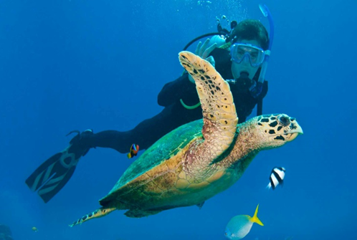 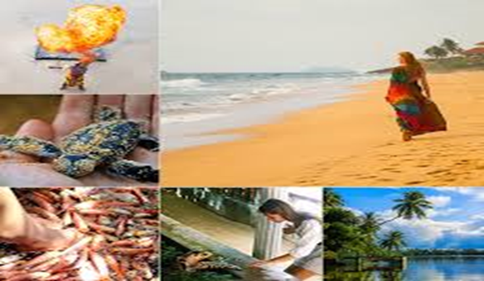

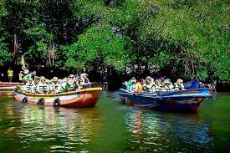 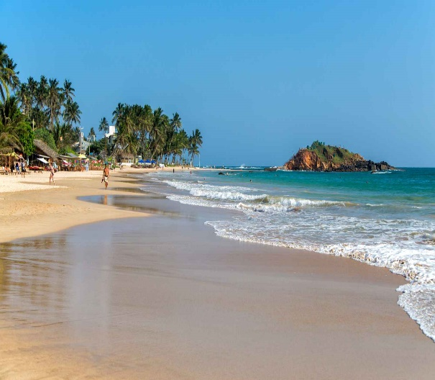

After a hearty breakfast, start your day with a scenic **Madu River safari**, gliding through serene mangroves and spotting diverse wildlife in this biodiverse haven. Along the way, you may encounter vibrant birdlife, water monitors, and small islands with cinnamon plantations.

Later, visit a nearby **turtle hatchery farm**, where you’ll learn about sea turtle conservation and have the chance to see these gentle creatures up close. As the day winds down, relax by the beach, letting the soothing waves and golden sands provide the perfect backdrop for a tranquil evening.

**Overnight at Bentota.**

***Highlights of the day***

* Madu River Safari
* Sea Turtle Hatchery Farm
* Relax at the Beach

**Day 3: Bentota to Galle.**

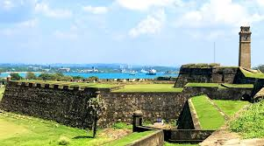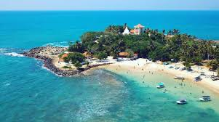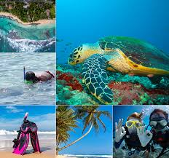

Embark today on a scenic journey from Bentota to Galle, where your first stop will be the fascinating **Stilt Fishing experience** at Koggala or Ahangama—an age-old tradition unique to Sri Lanka, offering a glimpse into the coastal life of local fishermen. Continue to the historic **Galle Dutch Fort**, a UNESCO World Heritage Site rich with colonial charm, cobbled streets, and iconic landmarks such as the lighthouse and ramparts. Dive deeper into the region’s heritage with a visit to the **Galle National Museum**, which showcases artifacts from the colonial era and traditional southern culture. Later, unwind at the golden shores of **Unawatuna Beach**, where you can relax by the waves or take a refreshing dip. Throughout the tour, enjoy **incredible photo opportunities and rich cultural immersion**, making this a perfect southern coastal experience.

**Overnight at Galle.**

**Distance from Bentota to Galle : 72 km**

**Travel Time: 2 hrs. 15 min.**

**Highlights of the day**

* **Stilt Fishing**
* **Galle Dutch Fort**
* **Galle National Museum**
* **Unawatuna Beach**

**Day 4: Galle.**

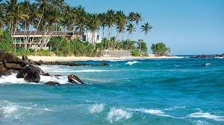 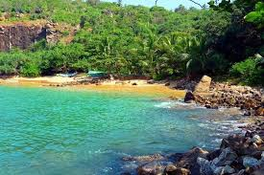

After your Breakfast you can visit Unawatuna Beach or Jungle Beach. Enjoy swimming, sunbathing, or snorkelingif weather permits for the same**.**

Or you can relax at the Beach hotel.

**Overnight at Galle.**

**Highlights of the day**

* **Unawatuna Beach**

**Day 5: Galle to Colombo.**

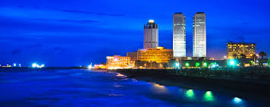 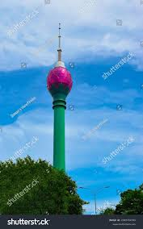

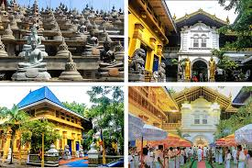 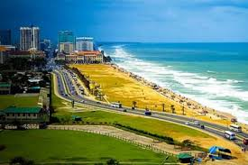

Today you will visit to your accommodation in **Colombo**,

you'll embark on an enriching city tour Colombo. The day begins with a **Viharamahadevi Park**, Colombo’s largest green space, ideal for a relaxing stroll. After lunch at a local restaurant, the tour continues with a visit to a prominent **Colombo mosque**, showcasing the city's rich cultural diversity.

Enjoy a leisurely walk along **Galle Face Green**, where you can take in the scenic views of the Indian Ocean. The highlight of the afternoon will be a visit to **the Lotus Tower,** offering breathtaking panoramic views of the city. As the day winds down, you’ll explore the **Colombo National Museum**, home to a vast array of historical and cultural artifacts. The day concludes with a delightful dinner at a local restaurant or your hotel, followed by a return to your accommodation to unwind and reflect on a day filled with exploration and discovery.

**Overnight In Colombo**

**Distance from Galle to Colombo : 130 km**

**Travel Time: 2 hrs. 10 min.**

***Highlights of the day***

* **Viharamahadevi Park**,.
* **Colombo mosque**,
* **Galle Face Green**,
* **Colombo National Museum**
* **Shopping**

**Day 6: Time to Say Bye -Colombo to Airport.**

Prepare to say "goodbye" to Sri Lanka as you have a hearty breakfast at the hotel before checking out. You will be taken to Bandaranaike International Airport, from whence you may continue to your home country.

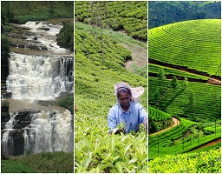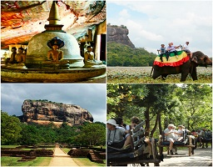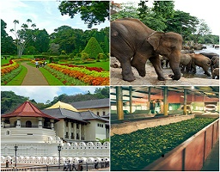**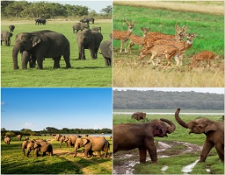Kandy Sigiriya Nuwara Eliya** 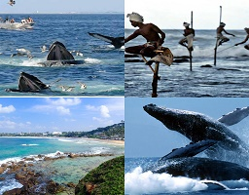

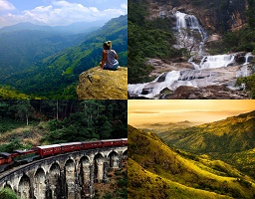

**Mirissa Minneriya National Park Ella**

**Option – 1- With Radisson Hotel Galle**

|  |  |
| --- | --- |
| **Privet Rates** | **USD** |
| **Total package for4 adults (Including all taxes)** | **1,196 USD (299 PP X 4)** |

**Hotels**

|  |  |  |  |
| --- | --- | --- | --- |
| **City** | **Hotel Name** | **Meal** | **Nights** |
| Galle | Radission Collection , Galle- Deluxe Room | Breakfast | 2 |
|  |  |  |  |

**Cab Details**

* Luxury Van for 6 Days and 5 Nights (vehicle type: Luxury Flat Roof Van (Caravan or KDH- depending on the availability)
* Seating Capacity:7 passengers + Luggage
* Transportation by air-conditioned private vehicle with an English-speaking chauffeur till the end of the enlistment
* Parking and paging at the airport
* Local insurance for the vehicle
* Passenger Insurance
* Highway Toll-Free
* GPS Monitoring Systems in Vehicles
* All taxes, fuel surcharges, and service fees are included.

**Inclusions**

* Meal Plan for the Hotel: as per mentioned
* GST, VAT, and Service Charges
* Water Bottle on Arrival (one mineral water bottle per person or per day)
* English-speaking chauffeur
* City tour and sightseeing
* 4 adults
* Accommodations in 02 double room.
* Meet and greet services with assistance at the airport.
* Complimentary SIM card for groups
* Arrangement of Foods for North Indian, Halal, Vegetarian, Non-Vegetarian, and Jain
* Chauffeur Meals and Accommodation

**Complementary Included**

* Visit the spice garden for complimentary herbal tea and drinks and a 15-minute head massage.
* Visit a Tea Factory or Tea Plantation with a Cup of Tea. Each Person
* Free visit to the art and craft center
* Free Visit to the Gem Museum and Lapidary
* Free Visit to the Ceylon Batik Factory
* Free entrance to the strawberry farm
* Free Entrance to the Colombo Casino

**Exclusions**

* Meal Plan for the Hotel: as per mentioned
* Entrance fees for music or site tickets
* Flight tickets and visa charges
* Train Tickets
* 4 x 4 Jeep for Safari
* Any expenses of a personal nature like laundry charges, tips, etc.
* Early check-in and late check-out
* Nothing else is mentioned in the inclusions.

**Conditions**

* The hotels mentioned above will only be confirmed on availability at the time of booking. If otherwise, suitable alternatives will be suggested before confirmation.
* The consumption of alcohol during “Poya Days” at bars, clubs, and other public areas of the hotel and the operation of similar forms of entertainment establishments is prohibited by law in Sri Lanka. It is recommended that clients contact reception to obtain their respective formalities during their holiday.

**Cancellation Policy**

* Cancellations within 01 to 06 days of the arrival date – 100% of the value of the booking
* Cancellations within 7 to 13 days of the arrival date – 50% of the value of the booking
* Cancellations within 14 to 28 days of the arrival date – 25% of the value of the booking
* Cancellations beyond 30 days of the arrival date – to be decided by the hotel on a case-by-case basis.

**Important**

* Hotel check-in time is 1400 hrs., and check-out is at 1200.
* All transfer times mentioned above are subject to variation depending on traffic flow and road conditions.

**Visa requirements:**

www.eta.gov.lk The visa will initially be limited to 30 days from the date of arrival, which may extend to six months by contacting the Department of Immigration and Emigration. This process will not be applicable for Singapore and Maldives passport holders as they are granted visas on arrival.

**Climate and seasons:**

In the Lowlands, the Climate is, in general, tropical, with an average temperature of about 27°C in Colombo. In Higher elevations, however, it can be quite cold, with temperatures going down to 16°C. Bright and Sunny days are the norm and are common even during the height of the Monsoon – climatically, Sri Lanka has no offseason. The southwest monsoon brings rain mainly from May to July to the western, southern, and central regions of the island. At the same time, the northeast monsoon rains occur in the northern and eastern areas in December and January.

**Other information**

|  |  |  |
| --- | --- | --- |
| **City** | **Place** | **Cost** |
|  |  |  |
| **Bentota** | Sea Turtle Hatchery & Rescue entrance fee | 10 USD per person |
|  | Boat charges for Madu river boat safari | 20 USD Per person |
|  |  |  |



Ms. Judi Sulakshana- 0094-776717091

Apical Lanka Travel

[www.apicallankatravel.com](http://www.apicallankatravel.com)

[judi@apicallankatravel.com/info@apicallankatravel.com](mailto:judi@apicallankatravel.com/info@apicallankatravel.com)